Which of the following in true in proper staging

* Only one idea should occur at a time

The first known animated projection on a screen

* Praxinoscope

Which of the following is not true about basic animation technique

* Lines should be bent towards

Opposite of anticipation the action that follows the main action

* Follow through

Proper staging can be applied to the following areas

* All of the above

The less complex the character is the harder it is to repeat over and over

* False

Frames of animation exist at the start and end of an action with frames of animation in the middle of that action this makes the movement more realistic

* More; Fewer

The pixel dimension measured in ipixel is the image size recognized by the

* Monitor

Also know as ease in and ease out

* Slow in slow out

A discrete unit that composing an image

* Pixel

Proper staging to control the viewers eyes can be described in the following statements except

* Main action should be at the border sides of the screens

A technique used in animation to bring still objects to life on screen by moving

* Stop motion

Which statements are true about animation?

* Animation tells a story

Which of the following is true in proper staging

* Only one ideas should occur at a time

Which is true about vector graphics

* All of the above

This actions adds to and enriches the main action and adds more dimension to the character animation supplementing and/or re-enforcing the main actions

* Secondary action

Choose three if the following that showed series of images to convey early ways of motion in arts

* Bayeux Tapestry , Shahr e Sukhteh, Vitruvian Man

The first animated series on prime time television released by Hanna Barbera

* Flinstones

In puppet animation, the puppet figures have or wireframe inside of them to keep them still and steady

* Armature

The term “Cel” in cel animation comes from

* The clear celluloid sheets that were used for drawing each frame

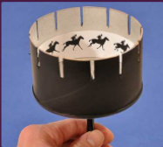

* Zoetrope

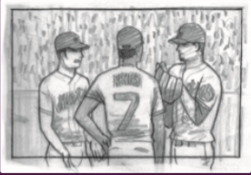

* Medium shot

Which of the following is incorrect in boosting the character’s appeal

* Magnify the things you find interesting to the character and

A circular card with slits around the edge. The viewer held card up to a mirror and peered through the slits as the card whirled a series of progressive drawings created a moving object

* Phenakistoscope

Still animal drawings in Paleolithic cave paintings are often depicted with in superimposed positions to convey the perception of motion

* Multiple legs

The less complex the character is the harder it is to repeat over and over

* False

Select the 3 examples of vector graphics

* Typeface, photograph, clipart

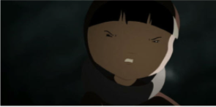

* Medium close-up shot

Corresponds to what would be called charisma in an actor a character who is not necessarily sympathetic villains or monsters can also fall ounder this principle – the important thing is that the viewer feels the character is real and interesting

* Appeal

The movement prepares the audience for a major action the character is about to perform, such as, starting to run, jump or change expression. Examples are a pitchers win-up or a golfer’s back swing

* Anticipation

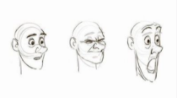

* Squah and stretch

Often called Claymation or clay animation that uses figures made of clay or a similar malleable material to create stop

* Plasticine animation

This terms means characters whose left and right side mirrored each other looked lifeless or boring

* Twinning

When drawing cubes, avoid making lines it will look like flat symbol or logo

* Parallel

Which device has two different drawings on opposite sides of a disk and when the disk is spun, the images merge into one

* Thaumatrope

When drawing your draft character, use the following basic solid shapes to construct the character

* Cube, cylinder, sphere

Most actions follow a slightly circular path. This is especially true of the human figure and the action of animals

* Arcs

36

Who said this inspirational quotes “if you can dream it you can do it” he created the animated characters like mickey mouse, Donald duck, and snow white

* Walt Disney

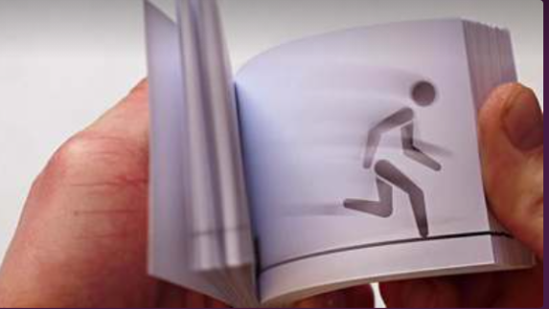

* Flip book

One means drawing out a scene frame by frame from beginning to end, while the other involves starting with drawing a few key frames, and then filling in the intervals later

* Straight ahead and pose to pose

Color mode used by computer monitor, TV, scanner, webcam and digicam

* RGB

Grayscale color mode has three channel

* False

The principle means taking into account forms in three-dimensional space, or giving them volume and weight. The animator needs to be as killed artist and has to understand the basics of 3D shapes, anatomy, weight, balance, light, and shadow, etc; also called artistry.

* Solid drawing

The first animated film used hand drawn animation, and is considered by film historians to be the first animated cartoon

* Fantasmagorie

A stop-motion technique that uses flat characters props and background from paper card fabric or photos

* Cut-out animation

What is staging

* Setting up the scene so that it is clear and understandable

Style of drawing describe as having a big heads with expressive faces and cute small bodies

* Chibi

When drawing a line on a sphere it must follow the contour of the spheres surface

* True